**Larry Comstock Real Estate & Contents**

**AUCTION**

No Reserve

***July 22, 2017 at 9:29 am***

***369 West Elkhorn Road, Salmon, Idaho***

**Auction Preview: July 21-22, 2017 - 1:00- 4:00pm MST**

**Featured Items: Partial Listing**

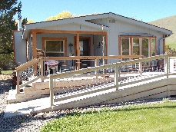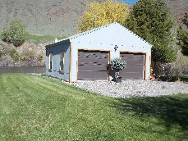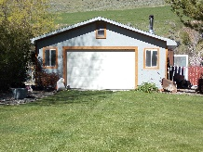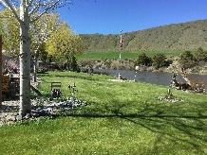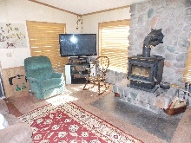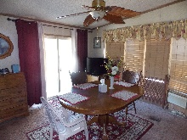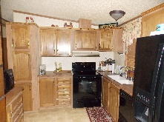

**REAL ESTATE**

**REAL ESTATE PRPERTY WILL SELL AT 12:30 PM**

**A Buyers Premium of 10% will be added to Real Estate final bid to determine final contract price**

**THREE (3) RIVERFRONT LOTS**

**Lot 38 – Block 11**

**Lot 39 – Block 11**

**Lot 40 – Block 11**

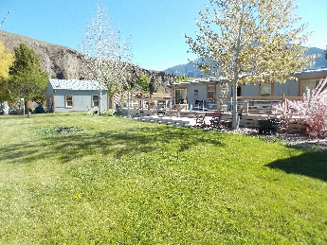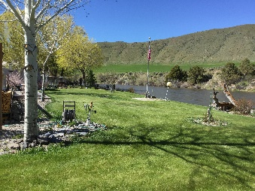

**RESIDENCE - BUILDINGS**

**1988 SEQUOIA 26X56 (1456 SQ. FT.)**

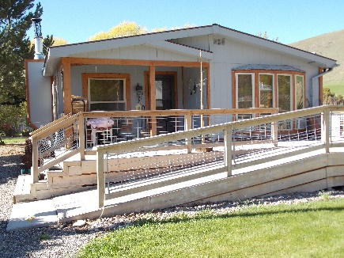**Three (3) Bedroom**

**Two (2) Full Bathrooms**

**Updated Kitchen**

**\*New Appliances**

***Absentee Bids NOW being accepted!***

***Bid ONLINE Now at:***

[www.openbucke.com](http://www.openbucke.com) ***or call us at  
Call (208) 940-1527***

***Lunch available for purchase…***

**Furnishings - Contents**

**PERSONAL PROPERTY WILL SELL AT 9:59 AM**

**No Buyers Premium No Minimum, No Reserve!**

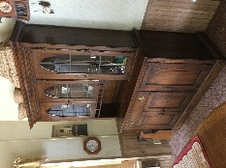**Furniture: s**ale includes **ALL CONTENTS**

of the home! **Antique Desk**, King size bed, single

Bed, **Gun Cabinet**, **Book Cases**, Glass top Coffee

Tables, **Dining Table** – Chairs, **Dressers**, China

Cabinets, **End Tables**, File Cabinets…MORE!

**Shop-Tools (ALL Contents of Shop)**

**Drill Press, Miter Saw, Folding Ladders,**

**scaffolding, Pneumatic Nail Gun, (2) Stand up Tool Chests,**

*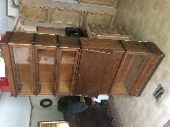***Power Washer, Air Wrench, Electric Chainsaws,**

**Electric wood splitter, Leaf Blower, Gas Grill,**

**Battery Charger, Air Compressor, Air Tank, Clamps,**

**Drills, Huge selection of Hand Tools, Floor Jack, Power**

**Saws, Shop Vac, Wheel Barrows, Folding Tables, Chairs,**

**Chimney Brush, Dremel Tool, Plumbing Fittings, Chain**

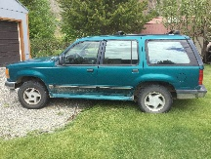**Link Dog Kennel, Electric Staplers, Roller Stand, MORE!**

**\*New Roof**

**\*New Wood Stove Installation 1994 Ford Explorer – New Tires, 134K**

**\*New Vinyl Windows**

**Dining Room**

**Large Wrap-Around Wooden Deck**

**Auction Terms and Conditions**

**REAL ESTATE: This is an ABSOLUTE Auction; No Minimum, No Reserve.** You must be registered to bid. A **$5,000.00** (five thousand dollar) non-refundable deposit will be required from the winning bidder upon the conclusion of the real estate auction. Deposit(s) must be in the form of cashier’s check, or pre-approved check. A 10% Buyers Premium will be added to the winning bid to determine final contract price of real estate only. Phone and Internet bidders welcome, but must be pre-registered with required $5,000 deposit held in bidder escrow. Contact Auction Company at 208-940-1527 for bidder deposit instructions by bank wire transfer. Closing to be within 30 days of auction.

**PERSONAL PROPERTY: This is an ABSOLUTE Auction; No Minimum, No Reserve. You must be registered to bid. There will be NO BUYERS PREMIUM on Personal Property purchased at this Auction. Cash, Check, Visa, MasterCard accepted. A 3% convenience fee will be required for credit card payments.**

**For complete registration and auction terms and conditions, please visit us at:**

**Large Living Room**

**Laundry Room**

**\*Installed within the last (2) years!**

**OUT BUILDINGS – Insulated, Wood Heated**

**24x24 ft. Two (2) Car Garage – Work Shop**

**20x20 ft. Single (1) Car Garage**

**Garden Shed**

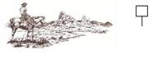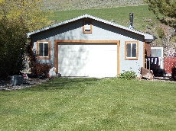 **OPEN BUCKLE AUCTION SERVICE**

13 Miller Lane

For Additional Information, Contact Us At: Salmon, Idaho 83467

**www.openbuckle.com** (208) 940-1527