**Antique Ranch – Lazy UH Ranch**

**AUCTION**

No Reserve!

No Minimum!

***May 9, 2015 at 9:29 am***

**Lazy UH Ranch, 24163 HWY 43 West, Wisdom, MT**

**Auction Preview: May 8, 2015 – 8 AM to 7 PM**

**Featured Items: Partial Listing**

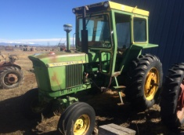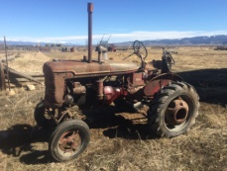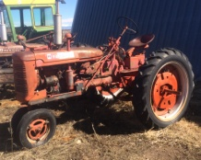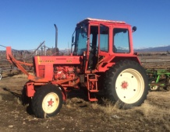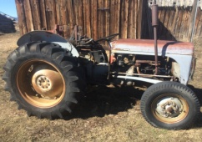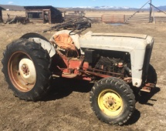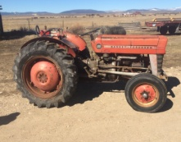

**Tract**ors

**Ford 600 (2)**

**Massey Ferguson 135**

**Harry Ferguson 35**

**International Harvester Farmall Super C**

**International Harvester Farmall H**

**International Harvester Farmall A**

**Belarus 825 Diesel**

**John Deere 3020 Diesel**

**John Deere 420 Dozer (2 Cylinder)**

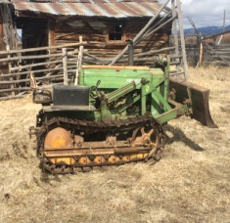Ranch Implements

**Ford Mowers, IH Mowers**

**Kosch Mower**

**Manure Spreaders**

**Post Hole Auger**

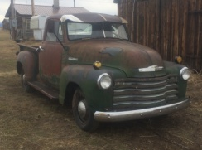**V-Ditcher**

**John Deere Seed Drill**

**Kelly Backhoe**

**Duall Front End Loader**

**Side Delivery Hay Rakes**

**Straight Dump Rakes**

**Hay rack (trailers and wagons)**

**Pickup Camper**

**Fertilizer Spreader**

Collectibles!

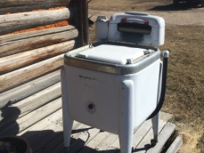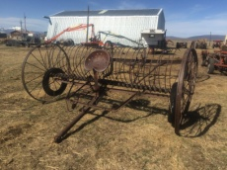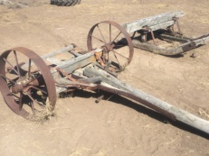

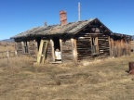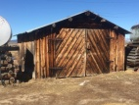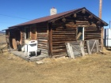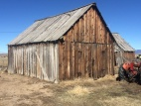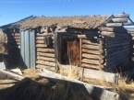

***Proxy Bids will be accepted!  
Call (208) 940-1527***

***Lunch available for purchase…***

***Catered by The Crossing***

*Too many items to list!*

Hard to find, and well cared for

Livestock Equipment

**Livestock Scale 1958 Chevy Apache**

**Calf Table GMC Stock Truck (Bad engine)**

**Head Catch etc.**

Haying Equipment

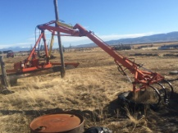**Grapple Hay Loaders**

**1962 Dodge Dump Truck**

**Stock Trucks**

**Loose Haying Equipment**

**Hoists (2)**

**Buck Rakes**

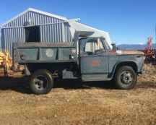**Round Bale Stabber, and more**!

Other Vintage Items

**Harness and Horse Collars**

**Old Visalia Saddle (pre 1936)**

**Hand Forged Items**

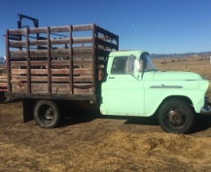**Beautiful Barn Wood (Buildings)**

**Vintage Log Cabins**

**Wood Stoves**

**Snow Machines**

**Tractor Tires and Wheels**

**Iron Wheels**

**Ringer Washers**

**Cream Separators**

**Old tools**

**Lumber, and much, much more!**

**DON’T MISS OUT! WE’LL SEE YOU THERE!**

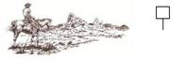*“There is something for everyone!!”* Proxy Bids Can Be Placed at (208) 940-1527

Auction Sale Conducted by: For additional Information Contact:

Open Buckle Auction Service John Nelson (406) 689-3181

13 Miller Lane Email: [jknelson@custertel.net](mailto:jknelson@custertel.net)

Salmon, Idaho 83467 **(208) 940-1527**

Rohn & John Nelson, Auctioneers

[www.openbuckle.com](http://www.openbuckle.com)